Compile and Run Java Program
Compile the program
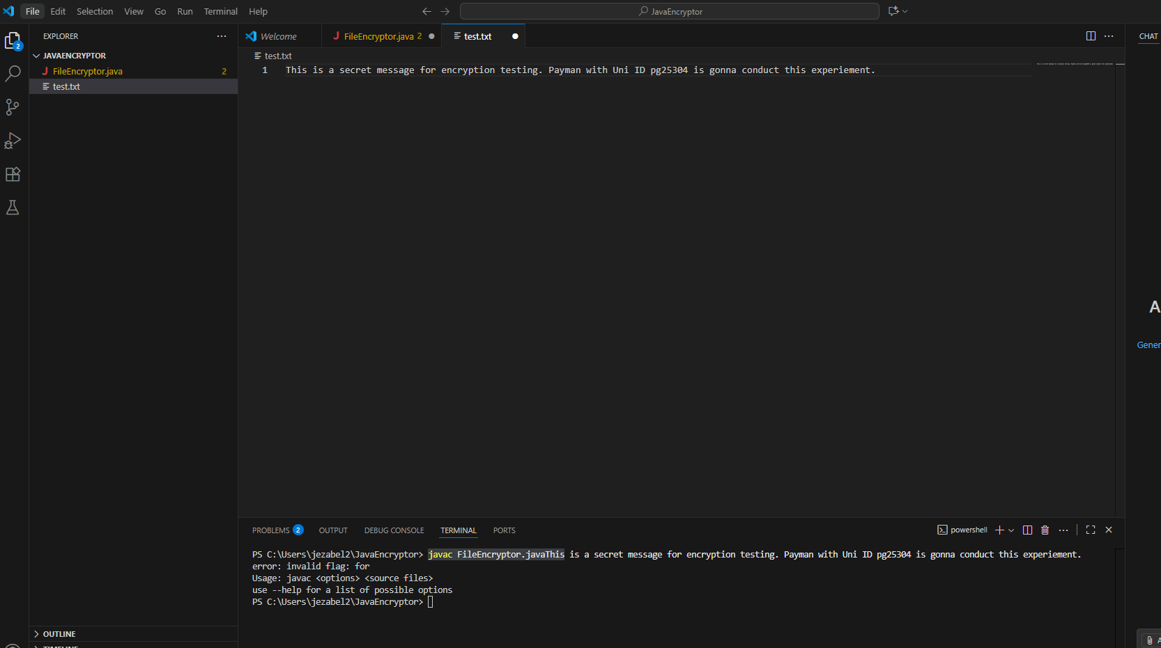
I could not Run the program and I receive an error message as follows:
Error: could not find or load main class FileEncryptor caused by: java.lang.classNotFoundException : FileEncryptor
I checked the directory by dir command to confirm that I am in the right folder, which I am but I could not see the FileEncryptor.class which confirm a successful compilation
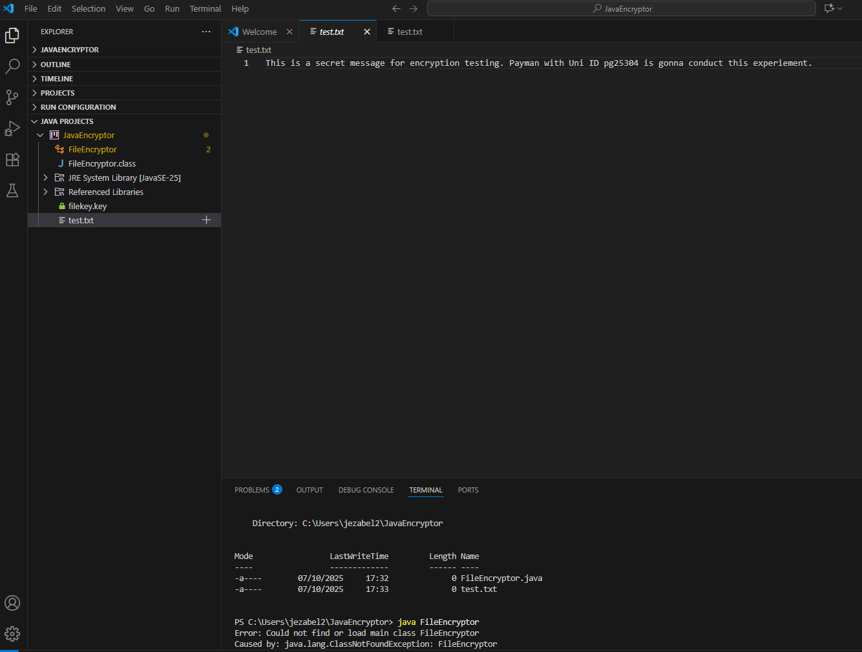
I compile and run the program again and this time I did not get any error . I checked the directory and I could see FileEncryptor.class
however the content is still looks as plain text not encrypted.
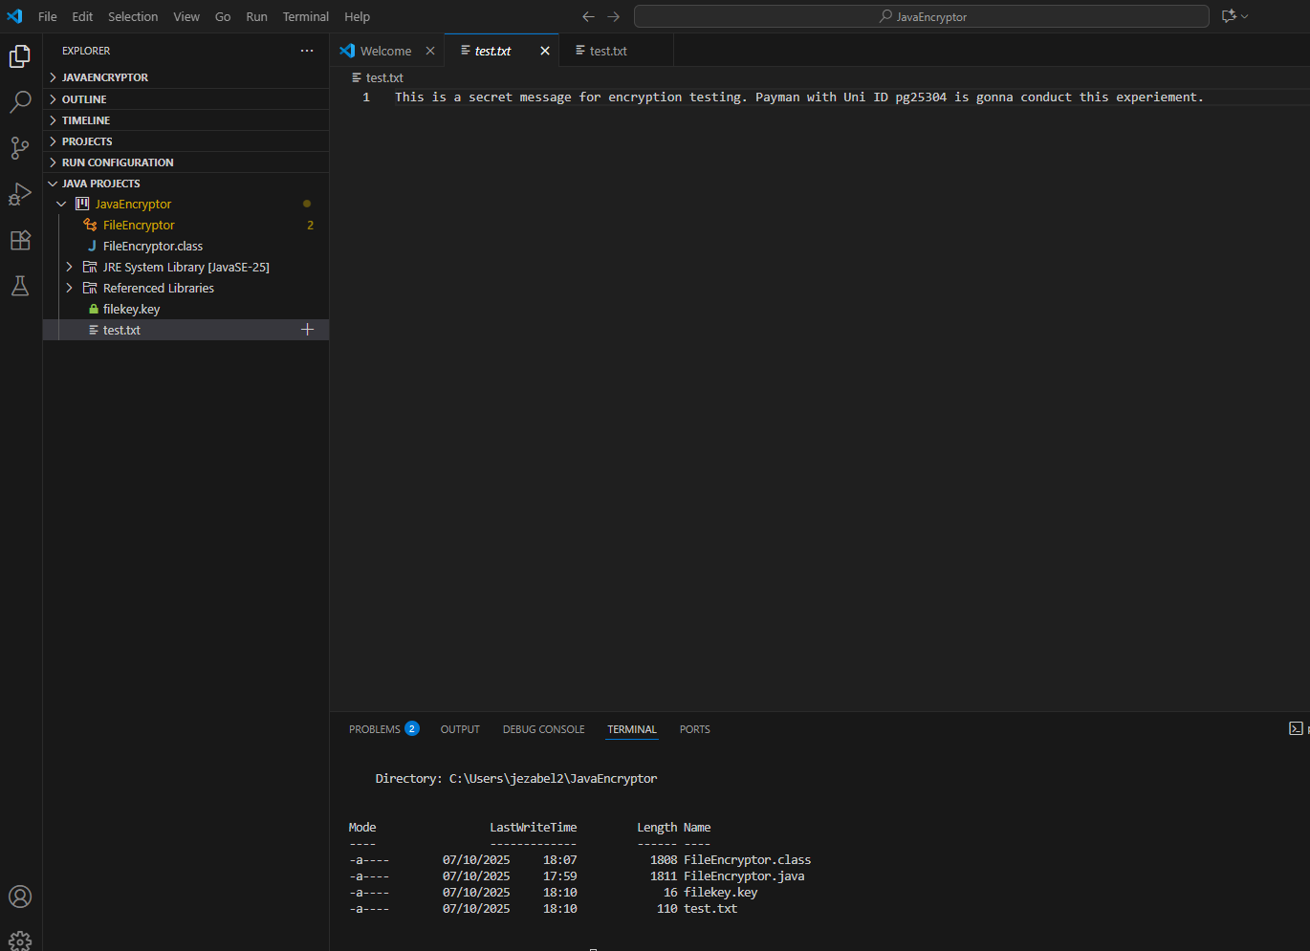

Further investigation revieled that the file content is being interpreted as plain text rather than binary.
I had to install Hex editor extension and open the test.txt with this editorto verify that the text has been encrypted
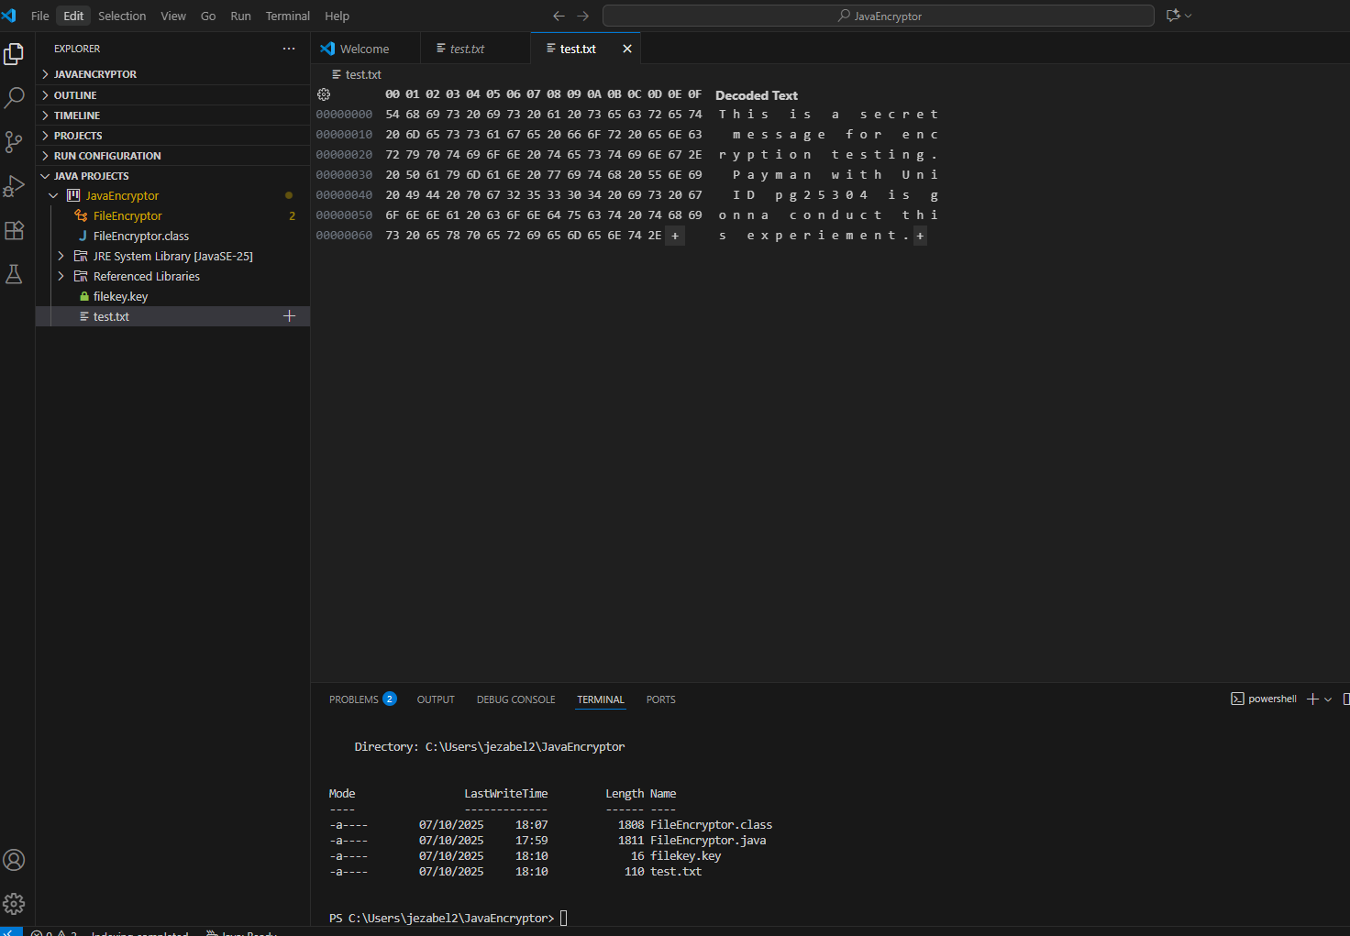
However I found another solution by modifying my programm by adding some new lines and made several lines as comments. I Added Console Output to Show File Content in Java. I modified the main() method to be able to verify the code directly in Terminal.
Afterwards I could see the following
Now when you run java FileEncryptor, you’ll see:
- Original content
- Encrypted content (scrambled)
- Decrypted content (restored)
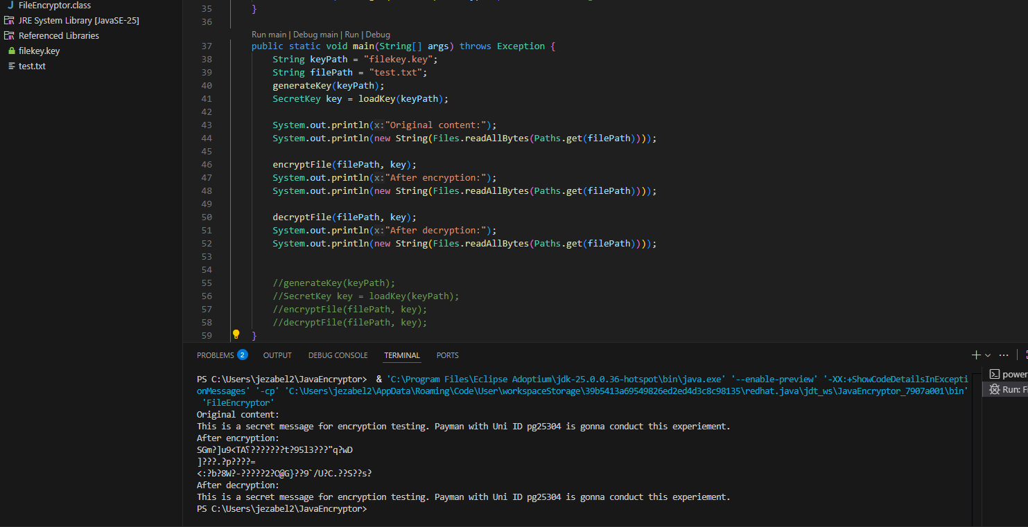
Unfortunately , Java does not have a built-in stopwatch but I could use System.nanoTime() to calculate how long each operation takes in nanoseconds, which you can convert to milliseconds for readability.
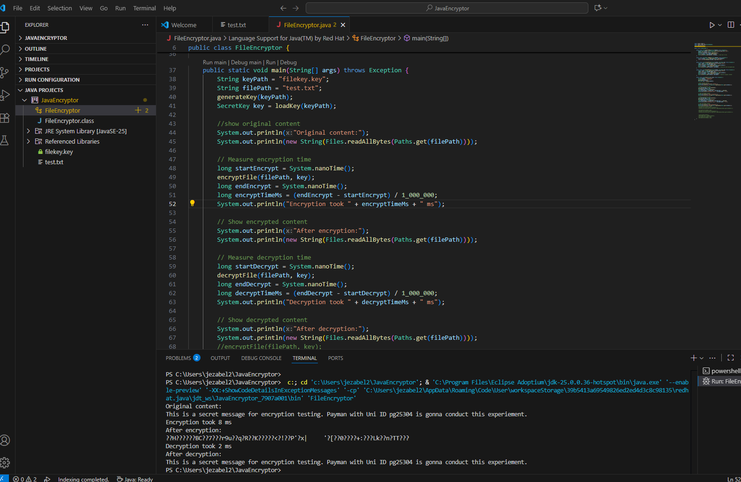
Completed java code:

import javax.crypto.*;
import javax.crypto.spec.SecretKeySpec;
import java.nio.file.*;
import java.security.*;

public class FileEncryptor {

public static void generateKey(String keyPath) throws Exception {
KeyGenerator keyGen = KeyGenerator.getInstance("AES");
keyGen.init(128); // AES-128
SecretKey secretKey = keyGen.generateKey();
byte[] encoded = secretKey.getEncoded();
Files.write(Paths.get(keyPath), encoded); // Save key to file
}

public static SecretKey loadKey(String keyPath) throws Exception {
byte[] encoded = Files.readAllBytes(Paths.get(keyPath));
return new SecretKeySpec(encoded, "AES");
}

public static void encryptFile(String filePath, SecretKey key) throws Exception {
Cipher cipher = Cipher.getInstance("AES");
cipher.init(Cipher.ENCRYPT_MODE, key);
byte[] fileData = Files.readAllBytes(Paths.get(filePath));
byte[] encrypted = cipher.doFinal(fileData);
Files.write(Paths.get(filePath), encrypted); // Overwrite with encrypted data
}

public static void decryptFile(String filePath, SecretKey key) throws Exception {
Cipher cipher = Cipher.getInstance("AES");
cipher.init(Cipher.DECRYPT_MODE, key);
byte[] encrypted = Files.readAllBytes(Paths.get(filePath));
byte[] decrypted = cipher.doFinal(encrypted);
Files.write(Paths.get(filePath), decrypted); // Restore original content
}

public static void main(String[] args) throws Exception {
String keyPath = "filekey.key";
String filePath = "test.txt";
generateKey(keyPath);
SecretKey key = loadKey(keyPath);

//show original content
System.out.println("Original content:");
System.out.println(new String(Files.readAllBytes(Paths.get(filePath))));

// Measure encryption time
long startEncrypt = System.nanoTime();
encryptFile(filePath, key);
long endEncrypt = System.nanoTime();
long encryptTimeMs = (endEncrypt - startEncrypt) / 1_000_000;
System.out.println("Encryption took " + encryptTimeMs + " ms");

// Show encrypted content
System.out.println("After encryption:");
System.out.println(new String(Files.readAllBytes(Paths.get(filePath))));

// Measure decryption time
long startDecrypt = System.nanoTime();
decryptFile(filePath, key);
long endDecrypt = System.nanoTime();
long decryptTimeMs = (endDecrypt - startDecrypt) / 1_000_000;
System.out.println("Decryption took " + decryptTimeMs + " ms");

// Show decrypted content
System.out.println("After decryption:");
System.out.println(new String(Files.readAllBytes(Paths.get(filePath))));
//encryptFile(filePath, key);
//System.out.println("After encryption:");
//System.out.println(new String(Files.readAllBytes(Paths.get(filePath))));

//decryptFile(filePath, key);
//System.out.println("After decryption:");
//System.out.println(new String(Files.readAllBytes(Paths.get(filePath))));

//generateKey(keyPath);
//SecretKey key = loadKey(keyPath);
//encryptFile(filePath, key);
//decryptFile(filePath, key);
}
}

